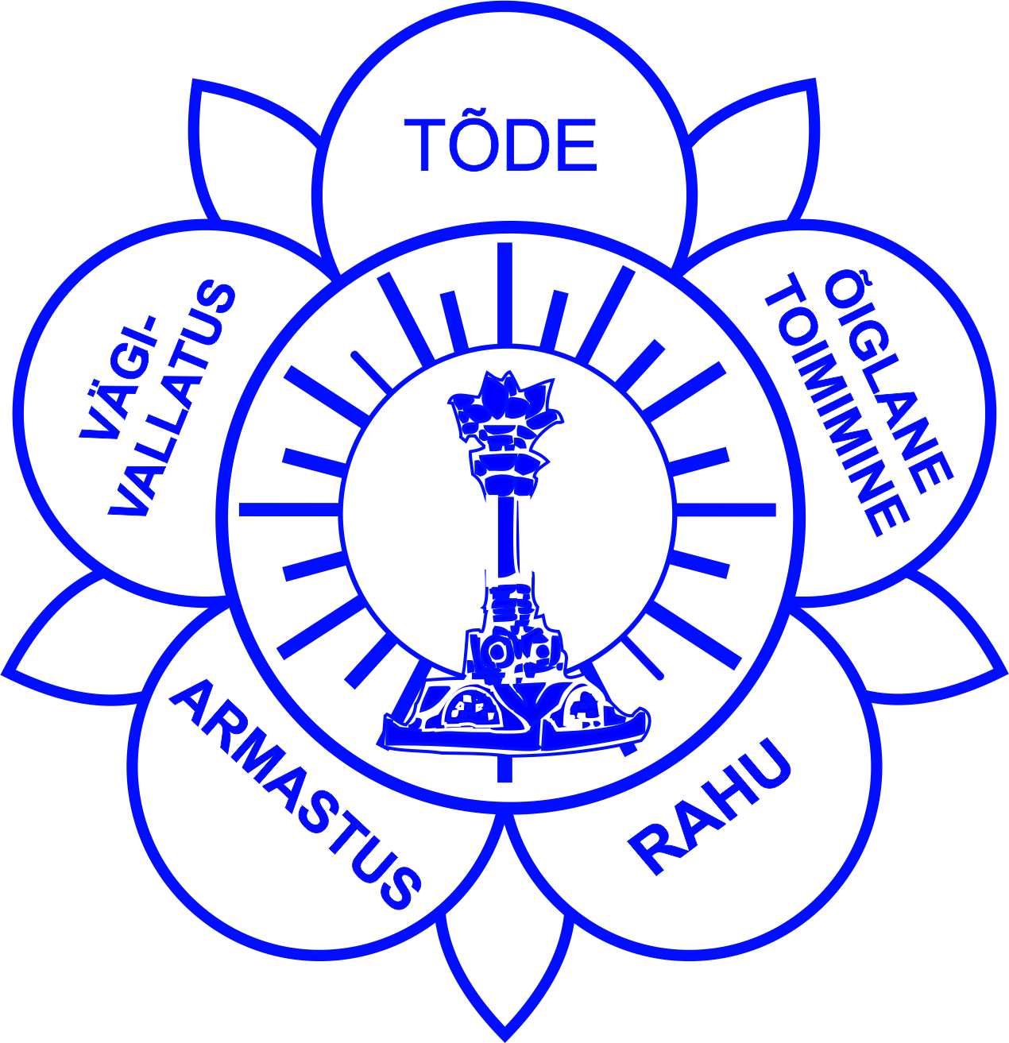
ESSE Institute
Leadership & Responsibility course,
Part I seminar – Tallinn, 24-26 February, 2012.

Planning this last seminar of the Leadership and Responsibility course, it was decided that it will take place from February 24th, which day is Republic Day in Estonia.
Venue was given to Estonian Sathya Sai Organisation by local private Art and Design School „Palitra“ owners, who co-incidentally are also Sai devotees and decided to give these rooms for our use without any cost.
Rooms were modest and just for such a small gathering – we expected participants from Pärnu Sathya Sai Group and Tallinn Sathya Sai Centre, 2 people from Finnish Sathya Sai Organisation and 4 from Latvian Sathya Sai Organisation + some more outside, altogether around 30 people.
Some of them were taking part of the seminar for a first time and were also enjoying this friendly and loving atmosphere.
From ESSE Institute two trainers were the leading force of the seminar –
Director of the ESSE Institute, Marianne Meyer (DK) (also member of the Prasanthi Council) and Petra von Kalinowski (GER), who is serving also as the Chair of the Zone 7.

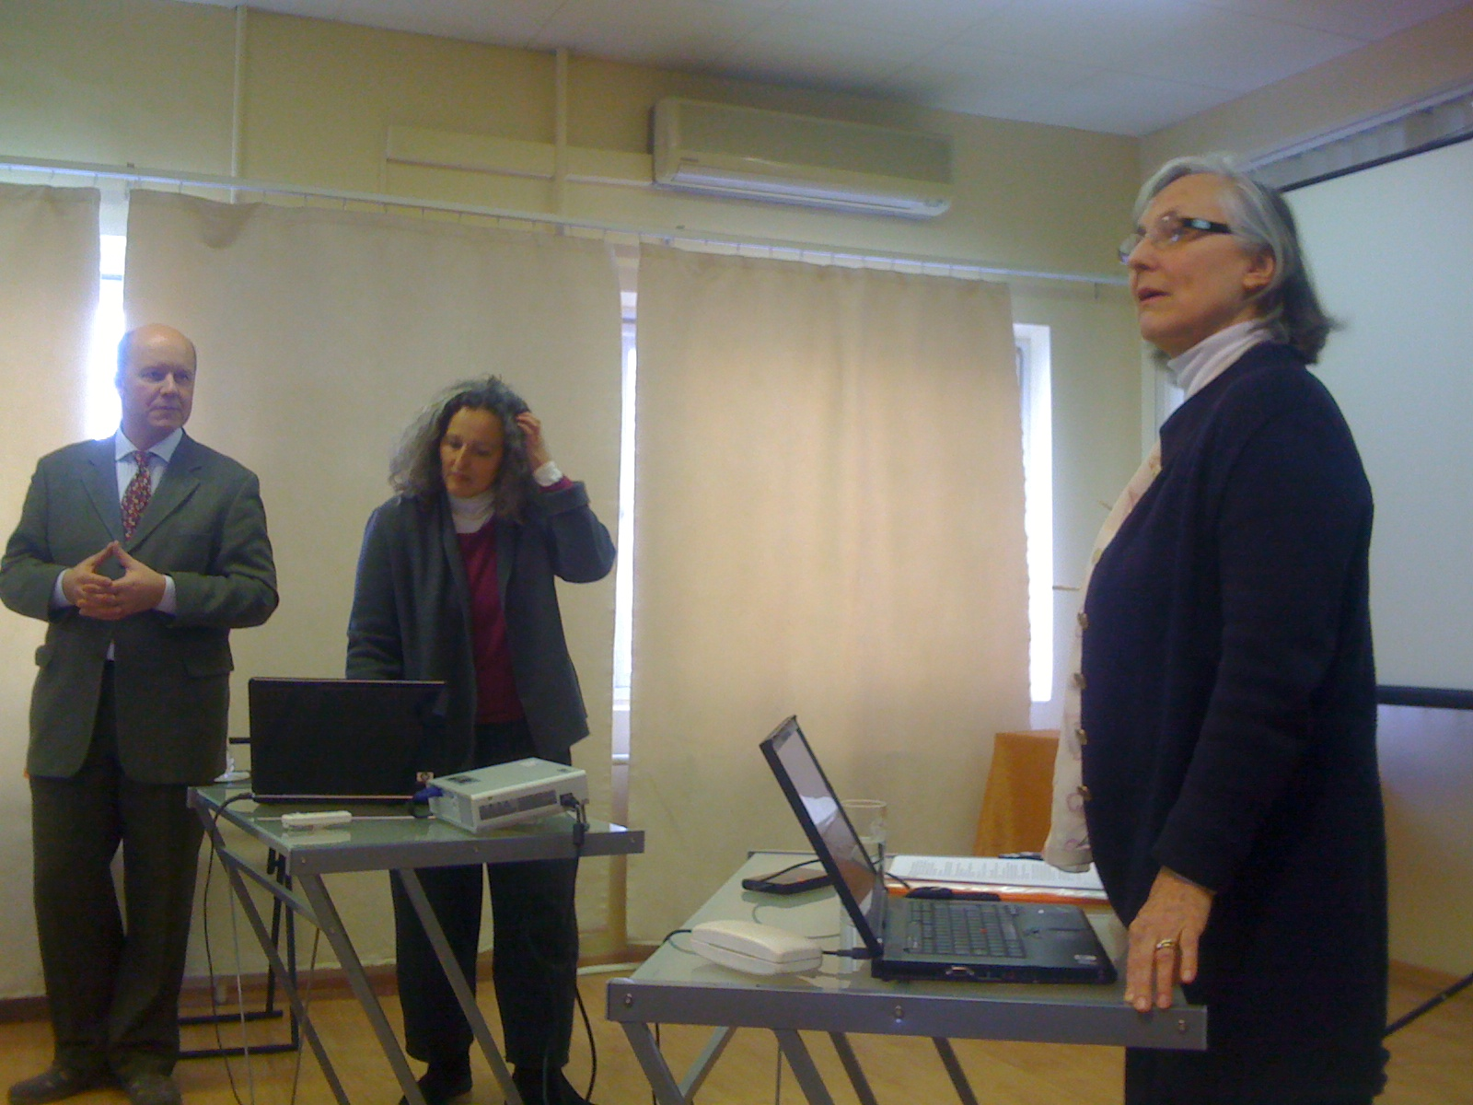
Marianne Meyer (on the right) and Petra von Kalinowski (in the middle) presented their topics with brilliant skills – they got translating assistance from Enn Kaljo, one of the aspirants and educational co-ordinator of Sathya Sai Centre of Tallinn.
On Friday we listened an Introduction with implementation into local culture, presented by Marianne Meyer – she explained and elaborated why it is so important to be one with our own culture and why we should not bring in alien rituals and even words when we cannot explain them to the newcomers and general public.

Petra von Kalinowski presented her topic about Group Devotional Singing, opening value of singing and understanding what we sing and what has been told about the power of the voice or sound in religious and philosophical sources, starting from Vedas and coming to those of authorities of present times. After a break Group workshop took place in several groups – idea behind was to find out and to bring out why it is so necessary to have lead-singers and how to select them. Second topic which was discussed was the dress code of the bhajan session. Third topic was to find songs in own culture or mother language that praise God or bring forth values....after groups worked almost half an hour leaders of the groups gave their summaries to everyone. Each group got the possibility to sing the song also – favorite of those which were found.

On Saturday we had long working day – despite of it all listeners were full of eagerness and enthusiasm listening actively and asking also questions when it was necessary and needed.
Marianne Meyer continued her presentation about Newcomers meeting, that was started already in last year seminar. She opened more about the Public Relations and Publishing matters as well as pointing out importance of the onepointed example of the leaders.
During the group work everybody had to find out what should be the qualities of the leaders in order to attract others with their love and open heart.
After that Petra von Kalinowski elaborated topic Co-ordination and Cooperation, bringing out what Swami has said about working together: „Co-operation, not operation!“ should be the aim. Details of the team work were brought before aspirants and in between the talk some songs were sung together from previous afternoon workshop. Petra opened this topic and enlightened listeners where coordination is needed – she told about Centre/Group level meetings, national, regional and zonal meetings.
Later, after lunch Petra continued with the same topic, going into details with 9 points and 10 principles as well as with the aims of Sathya Sai Organisation. She opened also matter of other meetings and issues needed to know around management of the Sai Centres/Groups.
Then Marianne Meyer spoke about Meditation and Meditation Classes and why these are important and bringing out how meditation can be facilitated, not taught and how leaders should themselves train for the guiding of Meditation Classes. She brought out that those members should have good meditation experiences themselves as well as to have light meditation as their sadhana. She opened up more about meditation, how to start, introducing the topics of concentration, contemplation and later meditation – bringing out comparison with falling into dream. Later she told us about breathing and how breath influences thought process. How to focus on positive thinking is also important, she said and she told about her own experience with meditation as well as letting everybody know more about delusions and how to work with feelings and images as well as with different things coming up from sub consciousness. Marianne also brought out the mirroring images from our own mind and intellect and need to clean these surfaces with mantra, japa and positive thinking and with putting ceiling on desires onto own wishes and desires. Small workshop was done on that topic and groups were discussing the questions some were asked as facilitator and how to answer them...
On Sunday everyone started with the beautiful afro-american spiritual song and then Marianne Meyer started to open up topic Communication and Cooperation, explaining more in detail what is active listening and how others may understand us if we don’t use our skills of giving our message clearly. She elaborated also how this world reflects our own construction – what we have put together and how our mind is projecting whole Universe and what we perceive with our senses. She brought out need to live in the NOW and pointed also to the processes and that even this living in NOW is a process which has to be aligned with our being and thinking and that we should use dialog and abandon all power games while communicating the others...and learn to listen empathetically.
Small workshop was done on active listening where every group elaborated on the message of the situation in hospital.

Seminar finished with questions and answers were both Marianne Meyer and Petra von Kalinowski answered questions of those who had something to ask. Everybody was happy that this lovely event took place and that we all had the opportunity to be present.

OM SAI RAM
Summary made by
Enn Kaljo (Educational co-ordinator of Sathya Sai Centre of Tallinn).

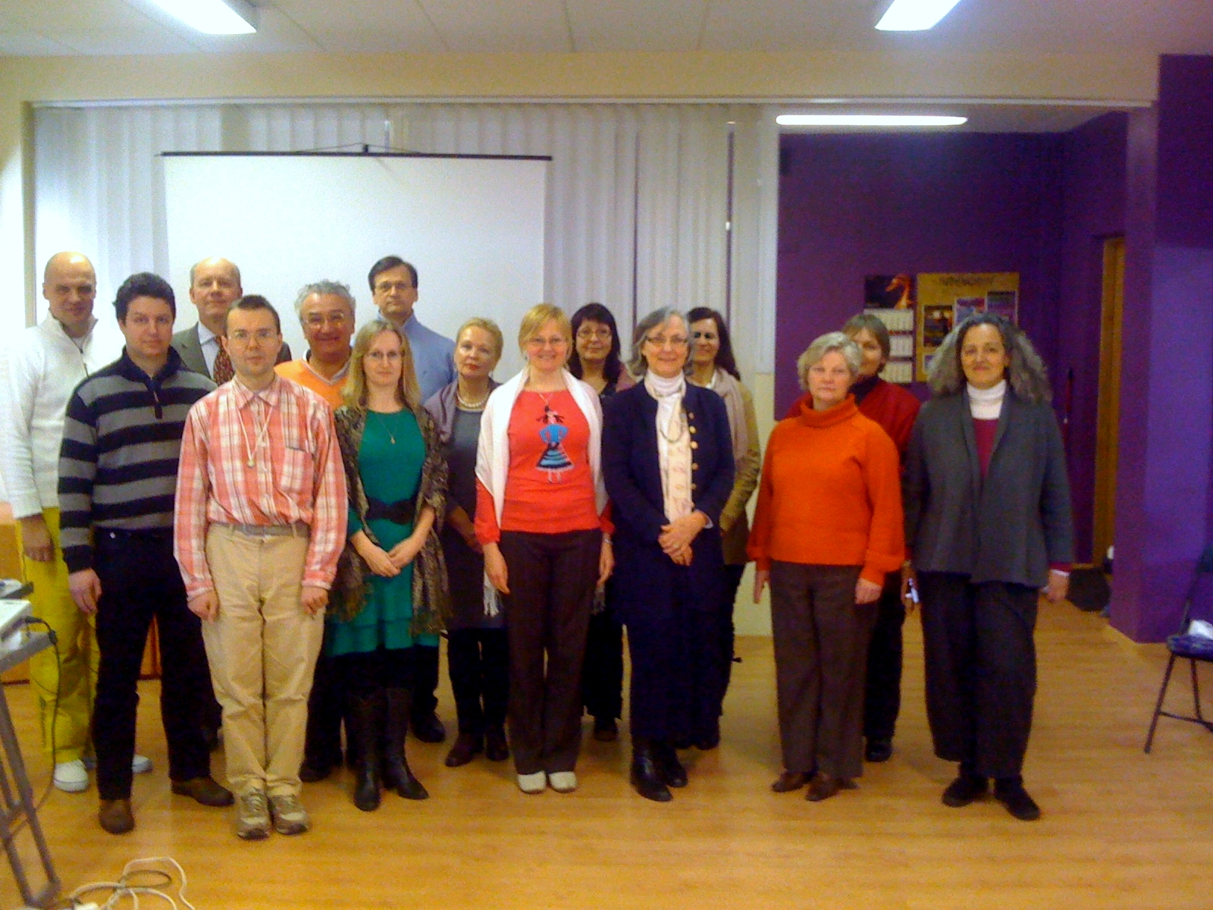
Group photo was taken at the end, when Latvians had already left to Latvia and some to their homes...Happy and satisfied faces tell us more than we can say with words.

